Net craft Analysis

What is net craft?
Net craft is a reconnaissance tool it gathers information like hosting provide service technologies, server type so guesses of the target it’s a powerful OSINT tool.
Net craft Working ;
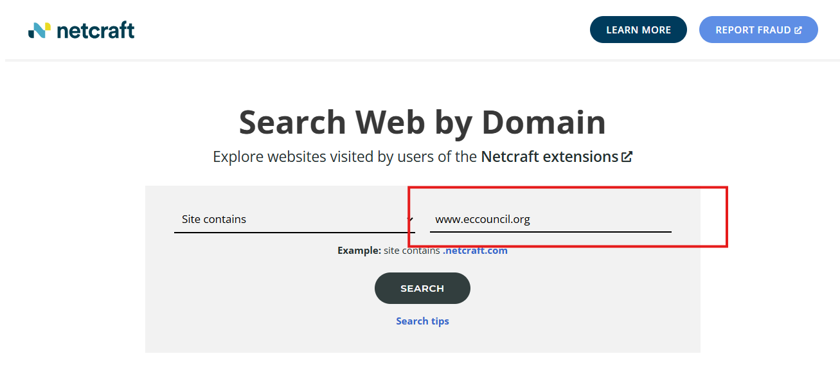
We will search for our target and then .

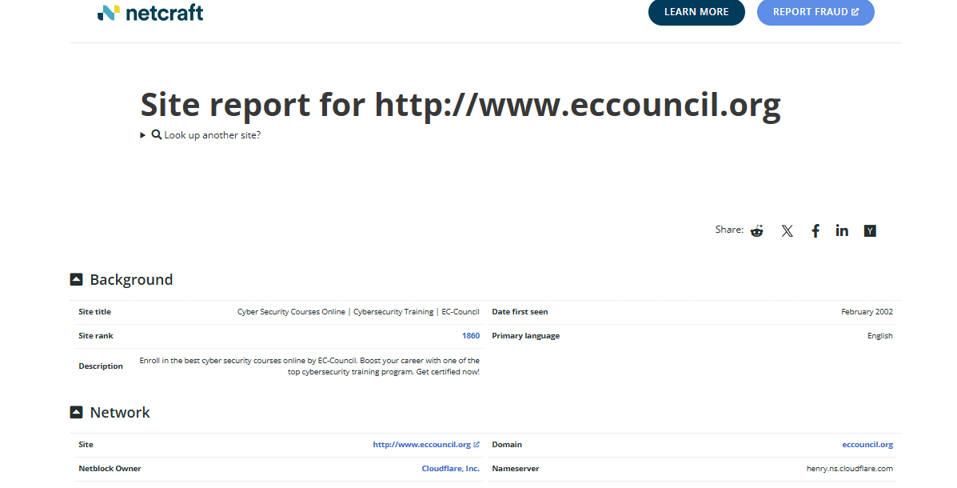

We got a lot of information like :
Hosting provider:
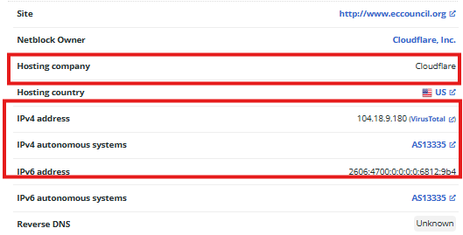
Web Technologies:
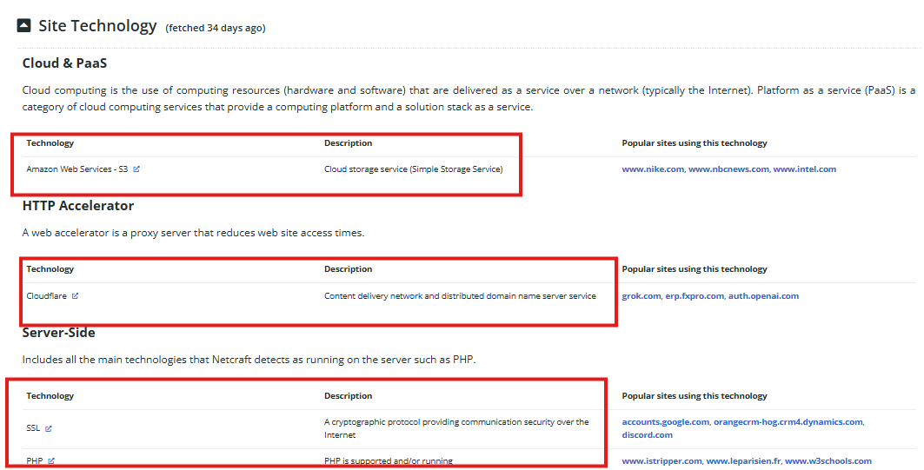
Domain name and server type
